Name: Khan Md Shahedul Islam

2020

Khan Md Shahedul Islam

Computer Netwrok

12/26/2020

Final Assignment

Student Id: 2018380130

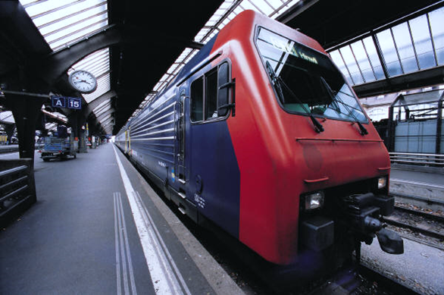

1. **In the store-and-forward packet switching network shown in the figure 1 below, the data transmission speed of all links is 100Mbps, and the size of a packet is 1000 bytes, in which the packet header size is 20 bytes.**

**(1) If the host P1 sends a file with the size of 68000 bytes to the host P2, without considering the packet assembly/disassembly time and propagation delay, how long will it take at least from P1 sending the file until all data having been received by P2?**

**Introduction:**

**Packet Delay**

There are various reasons why a package might be delayed. The main thing in the neighborhood network is the supposed data transmission delay: the time it takes the sender to get the organizer from the line. This is the parcel size isolated by the data transmission subsequent to everything is changed over to regular units (all pieces or all bytes). The data transmission of a 1500-byte bundle from Ethernet at a speed of 100 Mbps is 12000 pieces/(100 pieces/μs) = 120 μs.

There is additionally a deferral in proliferation, which implies an expansion in lice at the speed of light (for this transmitter). This is the distance between the delay and the speed of light. So if we start sending 1,500 bytes of the last segment at T = 0, the base number will be 1000 meters at T = 4 3, the final bit will be 120, and the final round will be T = 124 3.

**Minimizing Delay**

In the only remaining century, it was realized that players some of the time utilized moderately associated players, (for example, roundabout Connections). It tends to be killed straightforwardly without responding to the rival.

To counter this, some monetary exchanging companies have set up extraordinary microwave joins between business focuses, for example, New York and Chicago to lessen the accumulation. Milliseconds are significant in PC exchanging. There is a postponement of 125 KB of transfer speed of 1 ms for every 1 Gbps, however, it is all the more fascinating to defer the expansion. Direct view from New York to Chicago. Around 1,200 km of air possesses around 4 m noticeable all around, and the signs generally move. Be that as it may, fiber is slower. Indeed, even a totally straight line takes 6 ms. with a speed of 200 km/ms. of fiberglass duplication. On the off chance that a product change happens, this 2 ms. saving is significant monetarily.

As such, transmission capacity delay prevails in the nearby company.

In any case, as companies develop, playback postpones starting to prevail. This additionally applies to quicker companies: data transfer capacity is postponed, however, the engendering defer stays as before.

The principle contrast between the transmission capacity delay and the extension delay is that the transfer speed delay is relative to the measure of information sent, regardless of whether the transfer speed isn't deferred. In the event that we send two bundles in succession, the data transmission is multiplied; however, the postponement in the separation is determined just a single time.

The key ID is deferred during capacity and sending, the time has come to peruse the whole organizer prior to sending it back. Recording and sending deferrals can likewise be considered as extra transfer speed delays for the subsequent connection.

Subsequently, exchanging might be postponed; Be that as it may, the deferral in a specific line for every sender (for instance, because of around the normal burden on the tail) is by all accounts postponed in the spread. Thusly, stress that the couple is simply holding up in line.

**Delay examples**

Case 1: A──────B

The reason for the delay is 40 seconds

Bandwidth 1 byte / second (1 mB / second, 8 Mbit / second)

Packet size is 200 bytes (200 seconds of data transmission delayed)

Then the time to send a single thread without controversy is 240 240sec = 200 ease + 40 µsec.

**(2) Let (A, B, 8) represent the delay from the router A to the router B, then the communication subnet between P1 and P2 can be represented by (A, B, 8), (B, C,**

Case 2: A──────B

As with the previous model, the reproduction delay was extended to 4 ms

Total send time is now 4200 seconds / second = 200 seconds / 4000 seconds

Case 3: A──────R──────B

We now have two societies, each lasting 40 seconds. The bandwidth and packet size are the same as in Case 1

For a 200-byte series, the total delivery time will be 480 us = 240 + 240. There are two effects, each consisting of 40 mixed ingredients. Trading speed is 200 mAh, R interruption and data transmission (or second group delay) provide 200 mAh.

Case 4: A──────R──────B

Like 3, in any case, data sent in two sets of 100 bytes

The actual conversion time is now 380 ms = 3x100 + 2x40. Both features are delayed, but the delivery of the potential 100 bytes in the next community is equivalent to the delivery of the second 100 bytes in the central connection, as only 3/4 of the transaction speed is accepted.

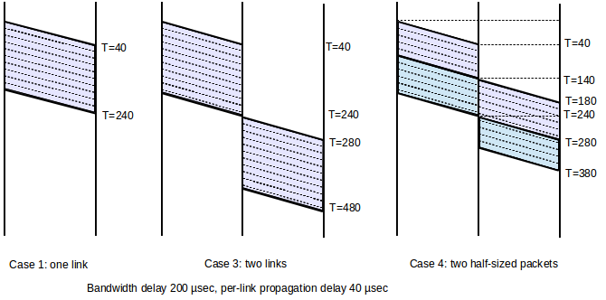

These ladders' plans speak to total progress; you can draw a line whenever during the exchange mode. For instance, on the off chance that 3, the two Connections are not dynamic by any stretch of the imagination. Note that sending two little bundles is quicker than sending an enormous parcel. We expand this significant point beneath

Presently consider the difficult that is the main piece of the augmentation delay. The hour of intercontinental travel between the United States is normally around 50-100 ms (transmission speed of 200 km/ms by link, 5000-10000 km, or around 3 km by link). 6000 miles); the models utilized here are 100 ms. 100 ms for every 10 Mbps is identical to around 12 KB or eight full-size Ethernet bundles. On account of this transfer speed, 100 bundles will have four parcels and four rounds of 10 Gbps ACK.

Distinctive postpone situations influence conventions: When network transmission capacity is restricted, conventions are simpler to arrange. The expense of extra RTTs isn't high, so we can add huge exchange trades. Nonetheless, when network inactivity is restricted, the convention engineer should zero in on lessening extra RTTs. In the most pessimistic scenario, think about remote (0 3 sec RTT) or pupate (1 hour RTT).

**4), (C, D, 3), (D, H, 5), (A, E, 5), (B, E, 2), (E, H, 3), (A, F, 6), (F, G, 3), (E,G, 1) and (G, H, 7). Suppose the distance vector routing algorithm is used here. Please explain after how many times of exchanges the routing tables can reach stable states, and take the router A as an example to draw all routing tables up to a stable state.**

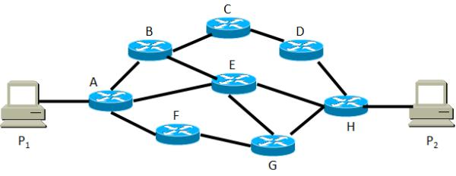

The house had a satellite Internet administration with a deferral of 600 pounds. High contrasted with ground Connections.

Companies are enormous companies with high transmission capacity, for example, the Internet, and generally, the vast majority of the line defers increment, so transfer speed and all out inertness is practically free. The distance and therefore the delay in spread may change when mobile nodes are added. Just when the engendering delay is little, this is because of two, in light of the fact that at this scale the spread postponement is transcendent; we can typically improve the outline. In the picture beneath, sends information bundle B and gets a little ACK. (A) we show that the information parcel goes through a few switches. (B) We speak to an information parcel sent by a long keyless reference and (c) we speak to a non-job romanticizing of transmission capacity delay (and consequently bundle line width) (a large portion of the later step graphs in this book)

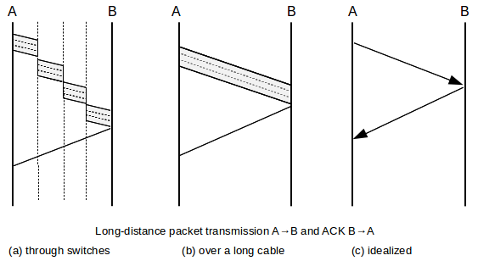

A bandwidth x delay product shows the amount we can spend before we get a reaction or the amount it will be "put away" on the Internet whenever in the event that we send it routinely. On the off chance that we use RTT rather than single direction time, half of the "normal" bundles will re-visitation the ACK. Here are a few implications

|  |  |  |
| --- | --- | --- |
| RTT | bandwidth | bandwidth × delay |
| 1 ms | 10 Mbps | 1 2 KB |
| 100 ms | 1 5 Mbps | 20 KB |
| 100 ms | 600 Mbps | 8,000 KB |

1. **Now, the system administrator wants to partition the address block 25.1.52.0/24 into five subnets. It is required that each subnet should accommodate as many hosts as possible, the ip address is not wasted, and 25.1.52.10 should appear in the No.1 subnet with the largest number of hosts. Please give the optimal design scheme, and write out the network address, subnet mask, available host IP addresses and direct broadcast address. (Assume all 1s and all 0s subnets can be used)**

Package delays

For certain associations, information transmission idleness and inertness have been changed, the first being the transmission speed and the second the light speed. This can prompt deferrals as a significant wellspring of advancement

In this specific circumstance, we can set the time from RTT to send the heap from A to B, so we can get affirmation.

While this is typically not the situation, a heap without RTT is generally not a gadget. There are a few objectives behind the advancing RTT. There is a fundamental "synchronization time" before you begin sending Ethernet and Wi-Fi. In spite of the fact that this postponement applies to sitting tight for different senders, it's anything but a line delay, and regardless of whether the parcel is sent first, there can be a huge deferral. Particularly for Wi-Fi, the vulnerability brought about by impacts during bundle conveyance can convolute higher idleness estimations, regardless of whether no other sender is contending.

It is likewise conceivable to route different packages to a number of other paths that cause small deviations during travel. The condition of optical parcel exchanging innovation is to some degree like electronic circuits before the creation of the coordinated circuit. Today, all the parts required for optical bundle exchanging are in a straightforward state and are in exploration research centers. For instance, optical support is made with several meters of postponing line, which is futile and can give just a restricted measure of memory.

The connection band can likewise change powerfully. For instance, consider a T1 connection comprising of a constant 24 DS0 channel that interfaces all channels not presently utilized with voice calls to one information channel. With eight guests, the information region is decreased from 24 × DS0 to 16 × DS0 by a third. On the other hand, switches can dispense various measures of transmission capacity for high traffic when required, in this way changing the transfer speed apportioned to the best traffic. The apparent connection transfer speed may change after some time as bundles are compacted in the connection layer and a few parcels are packed more than others.

As a result, the distance and therefore the delay in spread may change when mobile nodes are added. This can be significant when speaking with a remote gadget going on a mainland street.

Despite these sources of inconstancy, we think RTT no Load is all around characterized and very much characterized in the event that we need to zero in on the following piece of the deferral.

1. **A host H is linked to Internet through fast Ethernet，and its IP address is**
2. **168.0.8. The server S’s IP address is 211.68.71.80. H communicates with S based on TCP. Now 5 IP packets are caught in H, and their first 40 bytes in hexadecimal are shown in table 1 as follows, (Note：IP header size is only 20**

**Packet Size**

How huge should the bundles be? Should it be enormous (for example 64K) or little (for example 48 bytes)?

Ethernet's response to this inquiry was tied in with sharing a reasonable line: huge bundles would not permit different senders to get to the exchange on schedule. With any system, this difficulty keeps on being an issue.

The suggested optical frequency transducers for most designs are as yet in their earliest stages. The temperature reliance of the individual segments can be a significant issue of multiplexing, demultiplexing, or synchronizing signals with such high transient rates. Huge parcels, then again, lose a modest quantity of data transmission in headers. In any case, by and large, this won't surpass 10% (for example VoIP/RTP in 1 3 bundles).

The store has better execution of little bundles and forward catches. Connections on the two sides of the switch can be utilized all the while with 4/5 1 postpone models. This has an undeniable effect and has decreased interest in supporting IP jumbo grams. The ATM convention (expected for voice and information) closes with bundles with just 48 bytes of information and 5 bytes of headers.

For instance, think about a course from A to B with four catches and five Connections:

A───────R1───────R2───────R3───────R4───────B

Suppose you are sending an enormous bundle or five little bundles. The occasions contrasted with A to B appear in the accompanying figure:

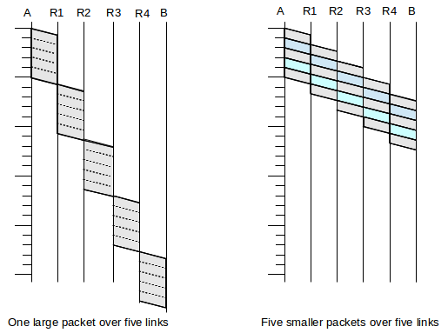

The fundamental concern is that we can utilize parallelism: the R4-B relationship above is bunch 1, the R3-R4 affiliation measure is pack 2, the R2-R3 affiliation measure is pack 3, etc. The headings of the littlest five packs will be on various events the size, in any case if the headers are little for information, that is really not a certifiable course of action.

The sliding window calculation utilized by TCP utilizes this thought as a decided cycle: the sender sends a consistent stream of controlled gatherings, so all Connections will be open at whatever point in the event that they are in full power.

1110 0110

┌───────────────

1011 │ 0110 0001 1100

101 1

─── ─

011 10

10 11

── ──

01 010

1 011

─ ───

0 0011 11

10 11

── ──

01 000

1 011

─ ───

0 0110

The simplest error-connecting code for representation is 2B, which requires an extra O (N1/2) digit. We get N × N digit data and spot it square. By then, we determine the value for each section, every segment, and the whole square. This is an extra 2N + 1 digit. Here are the graph and the condition with N = 4. The segment balance bits (in blue) are arranged in the pattern (fifth) and the line consistency bits (in blue) are in the right fragment (fifth). For a 4 × 4 information outline, the balance bit is the blue piece in the lower right corner 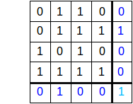

Again suppose the path from A to B has a single switch S in between: A───S───B

The per-link bandwidth and propagation delays are as follows:

|  |  |  |
| --- | --- | --- |
| link | bandwidth | propagation delay |
| A──S | 5 bytes/µsec | 24 µsec |
| S──B | 3 bytes/µsec | 13 µsec |

In the past exercise, except that the AS transmission capacity is under 3 bytes/µs and that the SB transfer speed is more noteworthy than 5 bytes/µs. What amount of time does it require for two 300-byte parcels in progression from A to B?

Suppose we have five links,

A───R1───R2───R3───R4───B

The bandwidth of every connection is 100 bytes/ms. suppose we model an increase in every connection

Assume that the way among A and B is connected with an equivalent band N, and we need to send M continuous parcels as appeared in the picture beneath.

1. **With the rapid development of communication and computer technology, especially the emergence and applications of big data, cloud computing, artificial intelligence, etc., new network technologies are emerging. Please introduce one new network technology, and give its features, implementation principles and applications briefly.**

A ─── S1 ─── ─── SN-1 ─── B

Photon packet switching networks offer the chance of executing bundle exchanging companies of bigger limit contrasted with electronic bundle exchanging networks. In any case, huge mechanical advances are expected to take them down to earth, and there are some significant hindrances that should be survived. The temperature reliance of the individual segments can be a significant issue of multiplexing, demultiplexing, or synchronizing signals with such high transient rates. The condition of optical parcel exchanging innovation is to some degree like electronic circuits before the creation of the coordinated circuit. Today, all the parts required for optical bundle exchanging are in a straightforward state and are in exploration research centers. Hefty to utilize, extremely convoluted or pricey. For instance, optical support is made with several meters of postponing line, which is futile and can give just a restricted measure of memory. At speeds up to 100 Gbps and higher velocities, it is as yet a test to communicate information over significant distances.

As of now, rapid optical switches have higher misfortunes contrasted with polarization misfortunes and are not accessible for the necessary reconciliation for huge switches. The suggested optical frequency transducers for most designs are as yet in their earliest stages. The temperature reliance of the individual segments can be a significant issue of multiplexing, demultiplexing, or synchronizing signals with such high transient rates. Successful strategies are likewise expected to battle signal defilement from these switches. For instance, the modest 3R optical lines of a total optical regenerator examined in Chapter 38 will make the greater part of these models more advantageous. Soon, we will keep on actualizing all smart control capacities to supplant bundles in the power area.

